Onori Eugene O

PHYSICS DEPT, LASU.

PHY 103 (BASICS HEAT)

CONCEPT OF THERMODYNAMICS

1. **Link to YouTube:** https://youtu.be/0W1JhIbJvz0

**Phy 103 (Basic Heat)**

**Module 3: THERMODYNAMICS**

**CONTENTS**

**Unit 1**: 1.0 Introduction 2.0 Objectives 3.0 Main Content 3.1 Definition of Thermodynamics 3.2 Idea of a System and its Surrounding 3.3 Thermodynamic Properties/Coordinates 3.4 Thermodynamic System 3.5 Thermodynamic Processes 4.0 Summary 5.0 Tutor-Marked Assignment.

**Unit 2:**1.0 Objectives 2.0 Thermodynamic Equilibrium 2.1 Mechanical Equilibrium 2.2 Chemical Equilibrium 2.3 Thermal Equilibrium 3.0 State of a System 3.1 Equation of State 3.2 The Ideal Gas 3.3 Van der Waals Equation of State 4.0 Extensive and Intensive Properties 5.0 Summary 6.0 Tutor-Marked Assignment.

**Unit 3:**1.0 Objectives 2.0 First law of thermodynamics2.1 work2.2 Heat engine2.3 Thermal efficiency2.4 Otto cycle 2.5 Carnot cycle 3.0 Entropy of a system. 4.0 Summary 5.0 Tutor-Marked Assignment.

**Unit 4:**1.0 Objectives2.0 Problem solving 3.0 Summary 4.0 Tutor-Marked Assignment 5.0 References/Further Reading

**UNIT 1: BASIC CONCEPTS OF THERMODYNAMICS**

**1.0 INTRODUCTION**

Every time you drive a car, turn on an air conditioner, or use an electrical appliance you reap the practical benefits of thermo- dynamics, the study of relationships involving heat, mechanical works and other aspects of energy and energy transfer. If you’ve seen demonstrations that use liquid nitrogen, you may have wondered how gases are liquefied. One method is first compressing the gas to very high pressure while keeping the temperature constant, then insulating it and allowing it to expand. The gas cool so much during the expansion that it liquefies. This is an example of thermodynamic process.To state energy relationships precisely, we need a concept of thermodynamic system.

Thermodynamics owes its origin to the attempt to convert heat energy into mechanical work and to develop the theory of operation of devices for this purpose. Two basic concepts in thermodynamics are work and heat. The zeroth law establishes the existence of thermal equilibrium and allows temperature to be measured using a thermometer. The first law places work and heat as the only way the internal energy of a system or a body can be increased. The second law talks about the entropy of a system. The first and second laws are used in explaining the operations of the Carnot engine, real heat engines and the refrigerators. Refrigerators are devices used to cool a system of a body and the process of doing this is called refrigeration cycle. The third law gives the condition for which a body or a system can be cooled to absolute zero i.e. an infinite number of refrigeration cycle. These four laws of thermodynamics i.e. zeroth, first, second and third laws are based on the observations made in the field of thermodynamics.

**2.0 OBJECTIVES**

By the end of this unit, you should be able to:

* explain what thermodynamics is
* mention all thermodynamics coordinates and explain change of state
* differentiate between a system and its surrounding.
* describe all thermodynamics processes

**3.0 MAIN CONTENT**

**3.1 Definition of Thermodynamics**

Thermodynamics is the study of the effects of work, heat, and energy on a system. Thermodynamics deals with the work heat exchanges of matter (solid, liquid or gas) within a specified region of interest or system. The system might be a mechanical device, a biological organism or a specified quantity of material such as the refrigerant in an air conditioner or steam expanding in a turbine. It deals only with the large-scale response of a system, which can be observed and measured in an experiment, of heat and work. Small-scale gas interactions are described by the kinetic theory of gases.

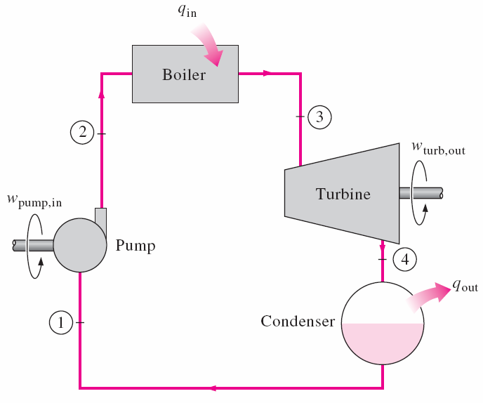

Figure 1: Thermodynamic system

**3.2 Idea of a System, surroundings and boundary**

***System*** is a restricted region of space or a finite portion of matter one has chosen to study. Or the part of the universe, with well-defined boundaries, one has chosen to study. In other words a system is a quantity of matter or a region in space chosen for study.

***Surrounding*** is the rest of the universe outside the region of interest (i.e. the rest of space outside the system or the mass or region outside the system).

***Boundary or Wall*** is the surface that divides the system from the surroundings. This wall or boundary may or may not allow interaction between the system and the surroundings.

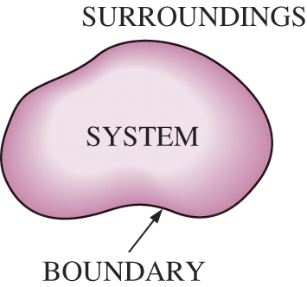

Figure 2: Showing System, surrounding and boundary

**3.3 Thermodynamic Properties/Coordinates**

These are macroscopic coordinates or properties used to describe or characterise a system. Because they are macroscopic properties or coordinates, they can be observed and measured. Some examples are Temperature (T), Pressure (P), Volume (V), density (ρ), mass (m), specific heat capacity at constant volume (VC), specific heat capacity at constant pressure (PC), thermal conductivity (k), thermal diffusivity (α), and chemical potential (µ).

**3.4 Thermodynamic System**

This is a system that could be described in terms of thermodynamic coordinates or properties. Thermodynamic Systems can be categorised into the followings depending on the type of boundary:

***Open System:*** This is a system that its boundary allows transfer of mass and energy into or out of the system. In other words, the boundary allows exchange of mass and energy between the system and the surrounding. (i.e. both mass and energy can cross the selected boundary).Example is an open cup of coffee

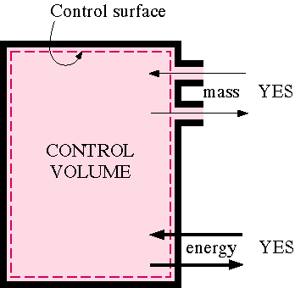

Figure 4: An Open System

***Closed System:*** This is a system that its boundary allows exchange of energy alone (inform of heat) between the system and its surrounding (i.e. the boundary allows exchange of energy alone). This type of boundary that allows exchange of heat is called diathermal boundary. Example is a tightly capped cup of coffee

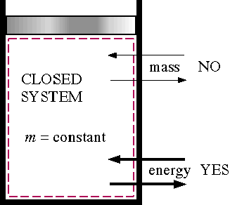

Figure 5: A Closed system

***Isolated System:*** This is a system that its boundary allows neither mass nor energy between it and the surrounding. In other words, neither mass nor energy can cross the selected boundary. Example (approximate): coffee in a closed, well-insulated thermos bottle.

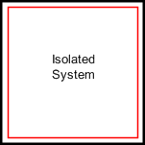

Figure 6: An Isolated System

**3.5 Thermodynamic Processes**

A system undergoes a thermodynamic process when there is some sort of energetic change within the system, generally associated with changes in pressure, volume, internal energy, temperature, or any sort of heat transfer.

There are several specific types of thermodynamic processes that happen frequently enough (and in practical situations) that they are commonly treated in the study of thermodynamics. Each has a unique trait that identifies it, and which is useful in analyzing the energy and work change related to the process.

**Adiabatic process:** This is a thermodynamic process in which there is no heat transfer into or out of the system. For this process, change in quantity of heat is zero (i.e.∆Q = 0 during this process)

**Isochoric process:** This is a thermodynamic process that occurs at constant volume (i.e. ∆V= 0 during this process). This implies that during this process no work is done on or by the system. **Isobaric process:** This is a thermodynamic process that occurs at constant pressure (i.e. ∆p = 0 during this process).

**Isothermal process:** This is a thermodynamic process that takes place at constant temperature (i.e. ∆T = 0 during this process)

It is possible to have multiple processes within a single process. A good example would be a case where volume and pressure change during a process, resulting in no change in temperature and no heat transfer. This kind of a process would be both adiabatic and isothermal.

**Cyclic Processes:** These are series of processes in which after certain interchanges of heat and work, the system is restored to its initial state.

For a cyclic process ∆U = 0 and if this is put into the first law W = Q.This implies that the net work done during this process must be exactly equal to the net amount of energy transferred as heat; the store of internal energy of the system remains unchanged.

**Reversible Process:** A reversible process can be defined as one which direction can be reversed by an infinitesimal change in some properties of the system.

**Irreversible Process:** An irreversible process can be defined as one which direction cannot be reversed by an infinitesimal change in some properties of the system.

**Isentropic process** - a process where the entropy of the fluid remains constant.

**Polytropic process** - when a gas undergoes a reversible process in which there is heat transfer, it is represented with a straight line, *PVn* = constant.

**Throttling process** - a process in which there is no change in enthalpy, no work is done and the process is adiabatic.

**Quasi-static Process:** This is a process that is carried out in such a way that at every instant, the system departs only infinitesimal from an equilibrium state (i.e. almost static). Thus a quasi-static process closely approximates a succession of equilibrium states.

**Non-quasi-static Process:** This is a process that is carried out in such a way that at every instant, there is finite departure of the system from an equilibrium state.

**SELF ASSESSMENT EXERCISE 1**

Explain the following:

i. open system ii. isolated system iii. isochoric process iv. isobaric process v. quasi-static process

**4.0 SUMMARY**

In this unit, you have leant that:

* thermodynamics is a branch of physics that deals with heat and flow of energy
* thermodynamics coordinates are used to characterize the state of a system and that a change in any or all of these coordinates brings about a change of state
* a system is a restricted region of space one has chosen to study while the rest of the universe is its surroundings. And that the system and its surrounding constitute the universe.
* base on the type of constraint imposed on a system, the system can undergo thermodynamics processes like adiabatic, isochoric, isobaric and isothermal processes
* equations of state are the known relation between the thermodynamic coordinate of a system

**5.0 TUTOR-MARKED ASSIGNMENT**

1. Explain the followings:

a. thermodynamic coordinate b. thermodynamic system c. open and isolated system d. cyclic process e. isobaric process

process e. reversible and irreversible process

2. differentiate between quasi static and non quasi static process

**UNIT 2: THERMODYNAMIC EQUILIBRIUM**

**1.0 Objectives:**

By the end of this unit, the student should be able to:

* Define thermodynamic equilibrium
* Explain mechanical , chemical and thermal equilibrium
* State Zeroth law of thermodynamics
* Explain the state of a system
* Differentiate between extensive and intensive properties of a system

**2.0 MAIN CONTENT**

**2.1 Thermodynamic Equilibrium**

Generally, a system is said to be in equilibrium when its properties do not change appreciably with time over the interval of interest (i.e. observation time).

A system is said to be in thermodynamic equilibrium with its surrounding or with another system if and only if the system is in thermal equilibrium, in chemical equilibrium and in mechanical equilibrium with the surrounding or with another system. If any one of the above conditions is not fulfilled, the system is not in thermodynamic equilibrium.

**2.2 Mechanical Equilibrium**

A system attains mechanical equilibrium with its surrounding or with another system when there is no unbalance or net force in the interior of the system and also none between the system and its surroundings or another system.

**2.3 Chemical Equilibrium**

A system attains chemical equilibrium when there are no chemical reactions going on within the system or there is no transfer of matter from one part of the system to other due to diffusion. Two systems are said to be in chemical equilibrium with each other when they have the same chemical potentials.

**2.3 Thermal Equilibrium**

This occurs when two systems in thermal contact or a system that is in thermal contact with the surrounding attains the same temperature. For example if system A with temperature T1 and system B with temperature T2 are in thermal contact, there will be exchange of heat between the two systems if there is a temperature gradient (i.e. when T1 ≠ T2 ). This process of heat exchange will continue until thermal equilibrium is attained (i.e. T1 = T2).

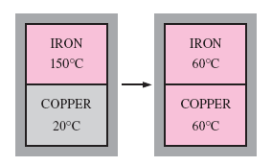

Figure 8: Two bodies reaching thermal equilibrium after being brought

into contact in an isolated enclosure

In thermodynamics, bodies are brought into contact in order to establish the common temperature using one of these coordinates. The two bodies may be in direct contact or they may be separated by two types of wall. The types of wall are namely adiabatic and diathermic walls. **Adiabatic walls** are those through which no heat can be transmitted whereas the walls through which heat can be transmitted are known as **diathermic walls.**

If system A is at a higher temperature than system B, when brought in contact with each other, then their state coordinates change. However, if the two systems are separated by insulating such as wood, plastic or fibre glass, the change in the state coordinate will be low or none. Such an insulating material is described as an adiabatic wall. Therefore, in general, an adiabatic wall is such in which, in an ideal situation, there is no change in the state of coordinates

This joint state of both systems that exist when all changes in the state coordinates have ceased is called thermal equilibrium.

**3.0 The Zeroth Law**

Consider two systems A and B separated from each other by an adiabatic wall but each system is in contact with a third system C. The zeroth law of thermodynamics states that:

*“If two thermodynamics systems A and B are separately in thermal equilibrium with a third system C, then the systems A and B are in Thermal equilibrium with each other”.*

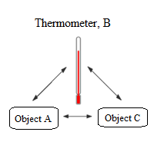

Figure 9: Illustration of Zeroth Law

The thermodynamic property which determines the thermal state of a system is the temperature *T*. Thus if *T*a, *T*b and *T*c are the temperatures of systems *A , B* and *C* respectively, the zeroth law states that if *T*a*=T*b and *T*a=*T*c, then *T*b=*T*c.

The zeroth law is thus used in establishing the temperature of a body quantitatively and objectively. But before it is measured, a scale must be established with the aid of a physical property which varies with temperature – the thermometer.

**SELF ASSESSMENT EXERCISE 2**

Explain what is meant by thermodynamic equilibrium.

**4.0 State of a System**

This is a specific situation in which macroscopic properties (thermodynamic properties) of a system have certain values (e.g. P=10 Pa, V=100 cm3, and T=300 K would be a state of a gas). It is important to note that the state of a pure substance or a system can be defined or specified by any two of its properties.Change of state occurs when there is change in one, two or all the properties of the system. Note: Change of state is not exactly the same thing as change of phase (Phase change). Change of phase or phase transition is a special case of change of state.

**4.1 Equation of State**

This is the known relationship between the thermodynamic variables or properties. It is an equation which provides a mathematical relationship between two or more state functions associated with matter such as its temperature, pressure, volume, or internal energy.

From the above descriptions, Boyle’s law, Charles’ law, Dalton’s law of partial pressures are examples of equation of state. Some other examples of equation of state are the ideal gas and Van der Waals equation of state.

**4.2 The Ideal Gas**

The equation of state for ideal gas is

PV = nRT (1)

where P is the pressure, V is the volume, R is the molar gas constant (R=8.314 JK-1mol-1), T is temperature in Kelvin, and n is the number of mole of gas.

**4.3Van der Waals Equation of State**

The equation of state for real gas also known as Van der Waals Equation is

(P + a/Vm)(Vm – b) = RT (2)

where quantities a and b are constants for a particular gas but differ for different gases.

There are many more equations of state besides these two given above.

**5.0 Extensive and Intensive Properties**

Properties of a system is a measurable characteristic of a system that is in equilibrium.

Properties may be intensive or extensive.

***5.1 Extensive properties:*** These are properties of system that depend on the mass of the system (e.g: mass, volume, energy, enthalpy)

***5.2 Intensive properties:*** These are properties of system that are independent of the mass of the system (e.g.Temperature T, Pressure P, and Density ρ).

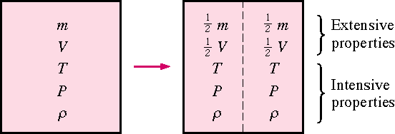

**SELF ASSESSMENT EXERCISE 3**

Explain extensive and intensive properties of a system.

**6.0 SUMMARY**

In this unit, you have leant that:

* a system is said to be in thermodynamic equilibrium with its surrounding or with another system if and only if the system is in thermal equilibrium, in chemical equilibrium and in mechanical equilibrium with the surrounding or with another system.
* Adiabatic walls are those through which no heat can be transmitted whereas the walls through which heat can be transmitted are known as diathermic walls.
* Zeroth law of thermodynamics states that “If two thermodynamics systems A and B are separately in thermal equilibrium with a third system C, then the systems A and B are in Thermal equilibrium with each other”.
* equations of state are the known relation between the thermodynamic coordinate of a system
* Extensive properties are properties of system that depend on the mass of the system (e.g. n, V and total energy U)while Intensive properties are properties of system that are independent of the mass of the system (e.g. T, P and ρ).

**7.0 TUTOR-MARKED ASSIGNMENT**

1. Explain the followings:

a. thermodynamic equilibrium b. thermal equilibrium c. extensive and intensive properties of a system

2. The equation for ideal gas is PV = nRT, suppose an ideal gas is in equilibrium at initial state with temperature T = 187 ºC, pressure P = 0.75 x 107 Nm-2, and volume V = 0.75 m3. If there is a change of state in which the gas undergoes an isothermal process to a final state of equilibrium during which its volume doubled, calculate the temperature and pressure of the gas at this final state.

3. State Zeroth law of thermodynamics and differentiate between adiabatic and diathermic walls.

**UNIT 3: FIRST LAW, HEAT ENGINE, SECOND LAW AND ENTROPY OF A SYSTEM**

**1.0 Objectives:**

By the end of this unit, the student should be able to:

* state the first law of thermodynamics
* define work and heat engines
* explain the Otto cycleand define thermal efficiency
* write equation of thermal efficiency and its usefulness
* state the second law of thermodynamics and explain Carnot cycle and entropy of a system

**2.0 First Law of Thermodynamics**

The first law of thermodynamic centers to the understanding of such processes, its an extension of the principle of conservation of energy. It broadens this principle to include energy exchange by both transfer and mechanical works and introduces the concept of the internal energy of the system. Conservation of energy plays a vital role in every area of physical science and the first law has extremely brought usefulness.

The first law is essentially that of conservation of energy. ***If a closed system absorbs a net amount of (heat) energy (Q) from its surroundings and does an amount of work (W), the balance (Q-W) is used in raising the internal energy (U) of the system.*** In mathematical notation

Q - W=∆U (3)

Where *∆U* is the change in internal energy of the system. If the system is taken from state 1 to state 2, then Q – W= U₂ - U₁, where U₁ and U₂ are values of the internal energy at state 1 and 2 respectively. Conveniently, heat added to a system is positive while heat released by the system is negative.

***2.1 Work*** is said to be done when any boundary of a system undergoes a displacement under the action of a force. Consider for instance, a system consisting of a gas under pressure ***P*** encased in a cylinder and piston unit. The cylinder walls and piston constitute the boundary of the system. The work done by the gas (***dW***) when the piston moves to the right under pressure *P* such that the volume of the gas increases by *dV* is

*dW* = *PdV* (4)

If the piston is moved through a finite distance so that the volume of the gas changes from Vᵢ to Vᵣ, the total work done is found by integrating the above equation

W = $\int_{V_{1}}^{V_{2}}{PdV }$ (5)

By convention, work done by the system is positive while work done on the system is negative.

**2.2 Heat Engines**

A *heat engine* is a device which produces work from a supply of heat. In such an engine, the working substance is usually taken through a cyclic process in which the initial and final states are identical. A common heat engine is the petrol (or ***gasoline***) engine, the type in which the work done is used in propelling an automobile.

**2.3 Otto cycle**

The working cycle for the petrol engine closely approximates the Otto cycle, which consist of four main processes:

1-2: Adiabatic compression of air-petrol mixture (the working substance) from atmospheric pressure to state 2 (compression stroke)

2-3: Heating at constant volume to state 3 (Combustion)

3-4: Adiabatic expansion to state 4 (Working stroke)

4-1: Cooling at constant volume to state 1 (Exhaust)

In this engine, heat Qₐ is added to the system during the combustion process while heat Qᵣ is rejected to the surroundings during the exhaust. The network output of the engine (*W*) is given by eq. (3).

For any system taken through a complete cycle, the internal energy at the initial and final states is the same. Applying the first law to the cycle gives

*Q – W = dU* = 0, *or Q = W*,

i.e. the network produced by the engine is equal to the net heat absorbed in a cyclic process. Since the net heat absorbed is equal to the heat added (Qₐ) minus the heat rejected (Qᵣ), the first law becomes, for a cyclic process

Qₐ - Qᵣ = W (6)

2.4 Thermal Efficiency of Heat Engine

The ***thermal efficiency* (ŋ)** of a heat engine is the ratio of the work done by the engine to the heat added, i.e.

ŋ = $\frac{W}{Q_{a}}= \frac{Q_{a}-Q_{r}}{Q_{a}}$ (7a

or

ŋ = 1 - $\frac{Q_{r}}{Q_{a}}$ (7b)

The most efficient engine is thus one for which the ratio Qᵣ/ Qₐ is made as small as possible.

**3.0 Second Law of Thermodynamics**

The first law of thermodynamics merely relates the amount of work derivable from an engine to the net heat absorbed by the engine without imposing restrictions on what fraction of the total heat added can be usefully converted into work. An ideal heat engine would be one in which all the heat added is converted into work, i.e. one in which Qᵣ = 0. Unfortunately, according to the second law of thermodynamics, such an engine cannot be built. This law can be stated as: “***It is impossible to construct an engine which absorbs heat from a reservoir at a single temperature and converts all of the heat to work. ”***The term **reservoir** is used to denote any part of a system which can absorb or release a large quantity of heat without showing an appreciable change in temperature. In the petrol engine, for instance, the continuous combustion of the air/fuel mixture provides the hot reservoir while the surrounding atmosphere, into which the exhaust gases are discharged, is the cold reservoir. While the first law states in effect that it is impossible to get more work from an engine than the (heat) energy supplied to it, the second law states further that it is not even possible to convert all of the heat energy supplied into work. In other words, some heat must be rejected (Qᵣ > 0), in which case W < Qₐ (eq. 14.4). It follows from eq. (14.5) that it is impossible to construct an engine which is 100% efficient.

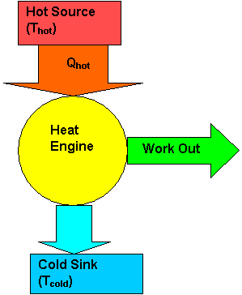

**Figure 10: Showing hot and cold reservoir**

**3.1 Carnot cycle**

There are several possible cycles through which the working fluid in a heat engine operating between two heat reservoirs can be taken. Although, according to the second law, none of these cycles an have an efficiency of 100%, it is of interest to know the maximum possible efficiency which can be attained. The ***engine*** is an idealized engine with such efficiency which will operate in an idealized cycle (***Carnot cycle***) which consists of four ***reversible processes.*** A reversible process is one which can be made to reverse itself without external aid. This is an idealized conception since in reality, no known process is reversible. The reversible process is analogous to the frictionless process in mechanics.

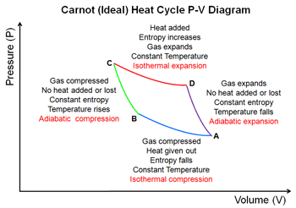

The Carnot cycle consists of four reversible process:

1-2: Reversible adiabatic compression of the working fluid from temperature Tc to temperature Th

2-3: Reversible isothermal expansion during which heat Qₐ is absorbed from the hot reservoir at TH

3-4: Reversible adiabatic expansion from TH to TC

4-1: Reversible isothermal compression during which heat Qᵣ is rejected to the cold reservoir at Tc

The work-heat exchange in a heat engine is often depicted schematically as shown in Fig. 14.4. The Carnot engine is the most efficient engine which can operate between two specified temperatures (TCand TH). For a Carnot engine, the ratio of the temperature of the two reservoirs is equal to Qᵣ/Qa, i.e.

$\frac{T_{c}}{T_{h}}=\frac{Q_{r}}{Q_{a}}$ (8a)

The efficiency of a Carnot engine is thus given by

ŋc= 1 – $\frac{T_{C}}{T_{H}}$ (8b)

In **v**iew of eqs. (7a) and (7b).

4.0 **Entropy**

Suppose a process is carried out from state 1 to state 2 through a series of small intervals along a

reversible path such that a small amount of heat ∆Q is added during each interval at which the system is at (absolute) temperature T. The ratio (∆Q/T) ᵣₑᵥ, when summed for the whole reversible path gives

2∫dQ/T (9)

The value of this integral for any reversible path depends only on the initial and final states of the process. A thermodynamic function is defined such that the differences between its values at state 1 and 2 is the same as the value of the integral. This function is the ***entropy*** (S) of the system. By definition,

S₂ - S₁ = $\int_{1}^{2}{\frac{dQ}{T}}$ (10)

For reversible path linking state 1 to state 2. For an infinitesimal change in the state of the system, eq. (14.8) can be written in differential form as

*dS = $\frac{dQ}{T}$* (11)

The change in entropy between any two equilibrium states is found by evaluating the ratio $\frac{dQ}{T}$ and performing the integral in eq.(14.8). The same computation is performed even if the process linking states 1 and 2 is irreversible (as in all real processes) although it must be understood that the entropy change thus computed is based on the premise that the two equilibrium states can be linked in principle by a reversible process.

**5.0 SUMMARY**

In this unit, you have leant that:

* The first law of thermodynamic is essentially that of conservation of energy and is given by Q - W=∆U
* Work is said to be done when any boundary of a system undergoes a displacement under the action of a force.
* a heat engine is a device which produces work from a supply of heat. The automobile engine is a typical example of a heat engine and it approximate a n Otto cycle.
* thermal efficiency (ŋ)of a heat engine is the ratio of the work done by the engine to the heat added, i.e. ŋ = $\frac{W}{Q_{a}}= \frac{Q_{a}-Q_{r}}{Q_{a}}$
* it is impossible to construct an engine which absorbs heat from a reservoir at a single temperature and converts all of the heat to work.” This is the statement of the second law of Thermodynamics.
* Carnot cycle is an idealized cycle that consists of four reversible processes.
* Entropy is the disorderliness of a system and is given by S₂ - S₁ = $\int_{1}^{2}{\frac{dQ}{T}}$

**6.0 TUTOR-MARKED ASSIGNMENT**

1. Explain the followings:

a. First law of thermodynamics b. Otto cycle c. heat engine and thermal efficiency

2. Discuss the Carnot cycle

3. State the 2nd law of thermodynamics and differentiate between a ot and a cold reservoir.

**UNIT 4: SOLVED PROBLEMS**

**1.0 Objectives:**

By the end of this unit, the student should be able to:

* Solve problems using the first law of thermodynamics
* Solve problems involving heat engines
* calculate thermal efficiency

**2.0 Main content**

**2.1 Solved examples:**

1. A 50 kg mass is placed on a fictionless piston fitted to a gas cylinder. If 149 J of heat energy is supplied to the gas cylinder, increasing its internal energy by 100 J, determine the height to which the mass on the piston is raised.

Soln

Q= 149 J, ∆U = 100 J

Q – W = ∆U

W = Q - ∆U = 149 – 100 = 49 J

But W = mgh

:. h = W/mgh = 49/ (50 * 9.8) = 0.10 m

2. Three moles of a gas expand Isothermally. If the initial temperature of the gas is 300 K and its final volume is twice the initial volume is twice the initial volume. Calculate the work done by the gas. Take universal gas constant = 8.314).

Soln

Pv = nRT and

W = $\int_{vi}^{vf}{pdV}$

= $\int_{vi}^{vf}{\frac{nRT}{V}}dV$

For an isothermal process, T = constant

Implying W = nRT $\int_{vi}^{vf}{\frac{dV}{V}}$ = nRTln[ $\frac{Vf}{Vi}$]

Since Vf = 2Vi, Vf/Vi = 2 hence

W = (3) (8.314) (300) ln2 = 5186.5 J

3. 50 g of ice is melted at the same temperature. Calculate the change in internal energy if the latent heat of fusion of ice is 3.35 x 105 J/Kg

Soln

First law: Q – W = ∆U

Here the work done is zero i.e. W = 0 and ∆U = Q = mLf

Hence ∆U = (0.05) (3.335 x 105)

= 1.68 x 104 J.

4. Compute the change in internal energy when 50g of water is turned into 8.4 x 104 cm3 of steam at 100oC under normal atmospheric pressure. The latent heat of vaporization of water is 2.26 x 106 J/kg.

Soln

First law: *Q – W = ∆U*

Since the vaporisation occurs at constant pressure we have

*W = P(Vf – Vi)*

*Vi* = initial volume of 50g of water (p = 1000 kg/m3)

= 0.05/1000 = 5 x 10-5 m3

Implying *W* = (1.013 x 105) (8.4 x 10-2 – 5 x10-5)

8.50Kj

Q = mLv= 0.05)(2.26 x 106) = 113.0Kj

*∆U = Q – W* = 113.0 -8.50

= 104.5 KJ

5.A gas stored in an insulated cylinder with a movable piston is compressed adiabatically and 100 J of work is done in the process. The gas is then allowed to expand adiabatically while doing 10 J of work. What is the net change in internal energy?

Soln

During adiabatic compression, work is done on the gas i.e. W is negative. Hence W = -100 J and Q = 0 (adiabatic)

:. *∆Uc = Q – W =0 –(-100) = 100J*

During adiabatic expansion, W =10 J and Q = o

:. *∆UE* = *Q – W* = 0 – 10 = -10 J

*∆UE* = Q – W = 0 = 10 = -10J

*∆U =∆Uc*– *∆UE*

*∆U = 100 – 10 = 90J*

6. A Carnot engine s operated between tow heat reservoirs at temperatures 400 K and 300 K. If the engine receives 200cal from the 400 K reservoir, (a) how many calores does it reject to the lower temperature reservoir? (b) What is the thermal efficiency of the engine?

Soln.

(a) For a Carnot engine, TC/TH = QR/QA

:. QR = QA * TC/TH = (2000) (300/400 = 1500cal.

(b) nc = 1 - TC/TH = 1 – 300/400

= 0.25 or (25%).

7.What is the maximum efficiency of an engine which operates between two reservoirs at temperatures of (a) 25oC and 40oC(b) 25oC and 100oC?

Soln:

The maximum efficiency is the Carnot efficiency.

(a) $η_{C}=1- \frac{T_{C}}{T_{H}}$, where $T_{C}$ = 25 +273 = 278 K and $T_{H}$ = 40 + 273 =313 K

$η_{C}$ = 1 – 298/313 = 4.79%

(b) $η_{C}$ = 1 – 298/373 = 20.11%

8.Calculate the change in entropy when 100g of ice at 0oC is converted to steam at 100oC. The latent heats of fusion of ice and of vaporization of water are 3.35 x 105 J/kg and 2.26 x 106 J/kg respectively and the specific heat of water is 4186 J/kgoC.

Solution:

Three stages must be considered separately. These are:

(1) the melting of ice at 0oC

(2) the heatng of water from 0oC to 100oC and (3) the vaporization of water at 100oC

Stage 1:

∆S = = (const. temp)

Q = mLv = (0.1)(3.35 x 105 = 3.35 x 104 J

T = 273 K

: ∆S1 = 3.35 x 104/273 = 122.7 J/kg.

Stage 2:

dQ= mcdT, hence ∆S2 =

= (0.1)(4186) = 130.6 J/K.

Stage 3: ∆S3 = (0.1) (2,26 x 106)/373 = 605.9 J/K

Overall change in entropy,

∆S= ∆S1 + ∆S2 + ∆S3 = 859.2 J/K

**3.0 Summary**

In this unit, you have leant how:

* to solve problems relating the first law of thermodynamics
* to solve problems relating to thermal efficiency of a system.
* to solve problems relating to entropy of a system.

**4.0 Tutor-Marked Assignment**

1. Calculate the work done by 0.5 mole of an ideal gas when its volume decreases from 10 L to 4 L, with temperature kept constant at 20oC. [Ans: -1.1 J].

2.A carnot engine operating between two reservors at temperatures 0oC and 100oC receives 10 kg of heat from the high- temperature reservoir. Calculate (a) the heat rejected to the low temperature reservoir, (b) the work done by the engine, and (c) the thermal efficiency. [ Ans:(a) 7319 J, (b) 2681 J, (c) 26.81%]

3. What is the change in entropy when 1 kg of water at 20oC is mixed with 1 kg of water at 100oC? (For water c = 4186 J/kg.oC) [Ans: 60.8 J/K].

4. A 0.5 kg piece of metal ( c = 600J/KgoC) at 300oC is dumped into a large pool of water at 20oC. Assuming the change in temperature of the water to be negligible, calculate the overall entropy change for the system. [Ans: 85.5 J/K]

**5.0 REFERENCES / FURTHER READING**

1. Ajaja O. and H.B. Olaniyi (2007). First- Year University Physics. Lamlad publications Vol. 1,pp 123 – 131.

2. Adams, Steve & Halliday, Jonathan, (2000). Advanced Physics. UK: Oxford University Press.

3. Francis, W. Sears & Gerhard, L. Salinger. (1975). Thermodynamics, Kinetic Theory, and Statistical Thermodynamics (Third Edition), Philippines: Addison-Wesley Publishing Company Inc..

4. Halliday, David., Resnick, Robert & Walker, Jeanrl. (2001). Fundamentals of Physics-Extended (Sixth edition). New York: John Wiley and Sons, Inc. John, D. Cutnell& Kenneth, W. Johnson (1989). Physics. USA: John Wiley & Sons, Inc.

5. Mark, W. Zemansky& Richard, H. Dittmann (1981).Heat and Thermodynamics (Sixth Edition). New York: McGraw-Hill Book Company.

6. Stuart, B. Palmer &Mircea, S. Rogalski (1996). Advance University Physics. SA: Gordon and Breach Science Publisher.

7, Rao, Y.V.C. (2004). An Introduction to Thermodynamics (Revised Edition). India: University Press (India) Private Limited.